SQL Querying Assignment – Employee Database Management System

Project Overview
This project demonstrates the implementation of SQL Query Language (DML & Data Retrieval) commands in MySQL by querying and analyzing an Employee Database Management System. The assignment focuses on retrieving, filtering, sorting, grouping, and aggregating employee data using SQL queries. It also demonstrates the use of various JOIN operations and Window Functions to generate meaningful business reports from a relational database.

Objectives
- Retrieve data from relational database tables using SQL queries.
- Apply filtering techniques using WHERE clause and comparison operators.
- Perform sorting and row limiting using ORDER BY and LIMIT.
- Generate business insights using Aggregate Functions.
- Group and filter summarized data using GROUP BY and HAVING.
- Retrieve related data using different JOIN operations.
- Perform analytical calculations using Window Functions.
- Develop industry-standard SQL querying skills for business reporting and data analysis.

Technologies Used
- MySQL 8.x
- MySQL Workbench
- SQL (DML & Querying Commands)

Database Schema

Database
Employee_DB

Tables Used

1. Departments
Stores department information.
Column | Data Type | Constraint
Department_ID | INT | Primary Key
Department_Name | VARCHAR(50) | NOT NULL, UNIQUE

2. Location
Stores employee work locations.
Column | Data Type | Constraint
Location_ID | INT | Primary Key
Location_Name | VARCHAR(50) | NOT NULL, UNIQUE

3. Employees
Stores employee information.
Column | Data Type | Constraint
Employee_ID | INT | Primary Key
Employee_Name | VARCHAR(50) | NOT NULL
Gender | VARCHAR(10) | NOT NULL
Age | INT | -
Hire_Date | DATE | NOT NULL
Designation | VARCHAR(100) | -
Salary | DECIMAL(10,2) | -
Department_ID | INT | Foreign Key
Location_ID | INT | Foreign Key

SQL Queries Implemented

DISTINCT Values
The following query retrieves all unique salary values from the Employees table.
Purpose:
- Eliminate duplicate salary records.
- Display only distinct salary values.

Column Aliasing (AS)
Aliases were assigned to improve readability of query results.
Examples:
- Age → Employee_Age
- Salary → Employee_Salary

WHERE Clause & Operators
The following filtering operations were performed:
- Employees earning more than ₹50,000.
- Employees hired before 01-Jan-2016.
- Updated missing Designation values with "Data Scientist".
Concepts Used:
- WHERE
- AND
- Comparison Operators (>, <)
- IS NULL
- UPDATE

ORDER BY
Employee records were sorted by:
- Department_ID (Ascending)
- Salary (Descending)
Purpose:
Generate organized reports for salary comparison within departments.

LIMIT
Retrieved the first five employees hired during the year 2018.
Purpose:
Restrict the number of records returned by the query.

Aggregate Functions
The following aggregate functions were implemented:
- SUM()
- MIN()
- AVG()
Business Reports Generated:
- Total salary expenditure in Finance department.
- Minimum employee age.
- Average salary calculations.

GROUP BY
Employee records were grouped to generate summarized reports.
Reports Generated:
- Maximum salary for each location.
- Average salary for Analyst designations.

HAVING Clause
Filtered grouped records using aggregate conditions.
Reports Generated:
- Departments with fewer than three employees.
- Locations where female employees have an average age below thirty.

JOIN Operations

INNER JOIN
Purpose:
Display employee names, designations, and department names for employees assigned to departments.
Business Benefit:
Retrieve matching employee and department information.

LEFT JOIN
Purpose:
Display all departments along with the total number of employees, including departments without employees.
Business Benefit:
Identify departments that currently have no employees.

RIGHT JOIN
Purpose:
Display every location together with employees assigned to that location.
Business Benefit:
Identify office locations without employees.

CROSS JOIN
Purpose:
Generate every possible combination of departments and locations.
Business Benefit:
Useful for planning, allocation, and business scenario analysis.

SELF JOIN
Purpose:
Display employee pairs working in the same department while excluding self-pairs.
Business Benefit:
Identify employees belonging to the same department for collaboration analysis.

Window Functions

RANK()
Ranks employees based on salary from highest to lowest.
Business Use:
Identify highest-paid employees within the organization.

DENSE_RANK()
Ranks employees according to salary within each department without skipping rank values.
Business Use:
Department-wise salary ranking.

Running Total
Calculates cumulative salary for employees within each department.
Business Use:
Department salary tracking and payroll analysis.

SQL Concepts Covered
- SELECT
- DISTINCT
- AS (Alias)
- WHERE
- Comparison Operators
- Logical Operators (AND)
- IS NULL
- UPDATE
- ORDER BY
- LIMIT
- SUM()
- MIN()
- AVG()
- GROUP BY
- HAVING
- INNER JOIN
- LEFT JOIN
- RIGHT JOIN
- CROSS JOIN
- SELF JOIN
- Window Functions
- RANK()
- DENSE_RANK()
- PARTITION BY
- OVER()
- Running Total using SUM()

Learning Outcomes
By completing this assignment, the following SQL concepts were reinforced:
- Retrieving and filtering relational data.
- Applying sorting and row-limiting techniques.
- Using aggregate functions for business analysis.
- Generating grouped reports using GROUP BY and HAVING.
- Understanding relationships using JOIN operations.
- Implementing analytical reporting with Window Functions.
- Writing optimized SQL queries following industry standards.
- Translating business requirements into SQL logic.

MySQL Queries Used
The assignment includes SQL queries demonstrating:
- DISTINCT and Alias
- WHERE Clause and Comparison Operators
- UPDATE Statement
- ORDER BY
- LIMIT
- Aggregate Functions
- GROUP BY
- HAVING
- INNER JOIN
- LEFT JOIN
- RIGHT JOIN
- CROSS JOIN
- SELF JOIN
- RANK()
- DENSE_RANK()
- Running Total using Window Functions

Screenshots
Execution screenshots of all SQL queries and their outputs are included to verify successful implementation.

1. DISTINCT VALUES:
● A query to retrieve distinct salaries from the Employees table.

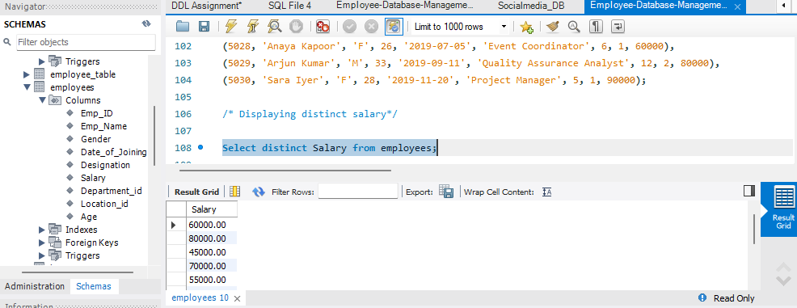

2. ALIAS (AS):

● Provide aliases for the "age" and "salary" columns as "Employee_Age" and
"Employee_Salary", respectively.

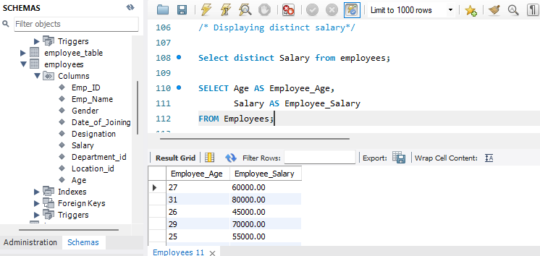

WHERE CLAUSE & OPERATORS:

● Retrieve employees with a salary greater than ₹50000 and hired before
2016-01-01.

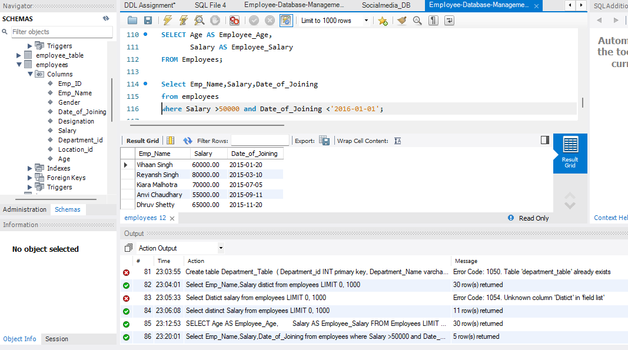
● Find the employee whose designation is missing and fill it with "Data
Scientist".

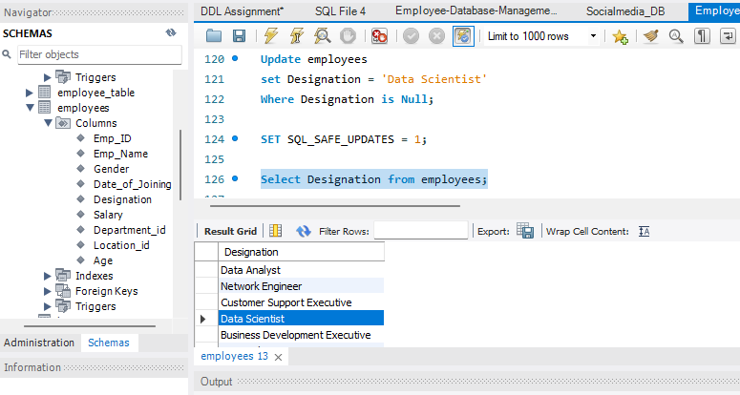

Sorting and Grouping Data:

1. ORDER BY:
● Find employees sorted by department ID in ascending order and salary in
descending order.

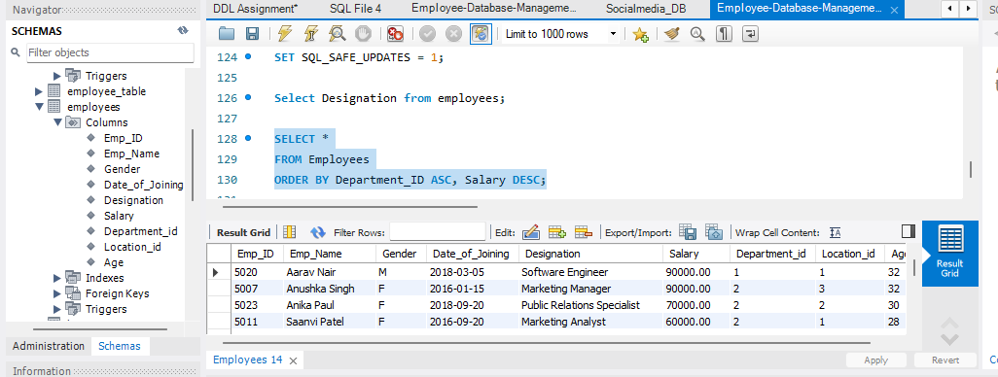

2. LIMIT:

● Display the first 5 employees hired in the year 2018.

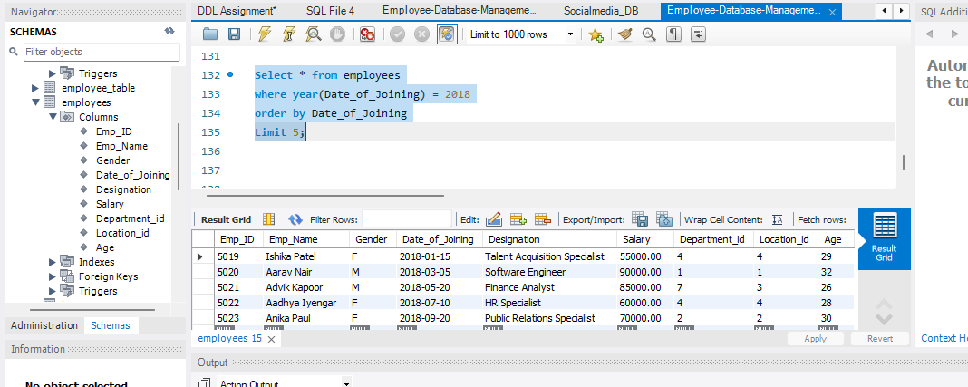

3. AGGREGATE FUNCTIONS:

● Calculate the sum of all salaries in the Finance department.
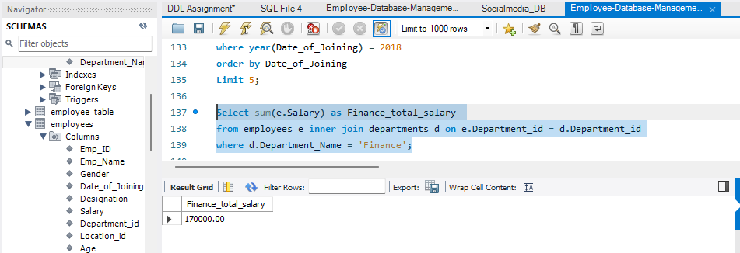

● Find the minimum age among all employees.

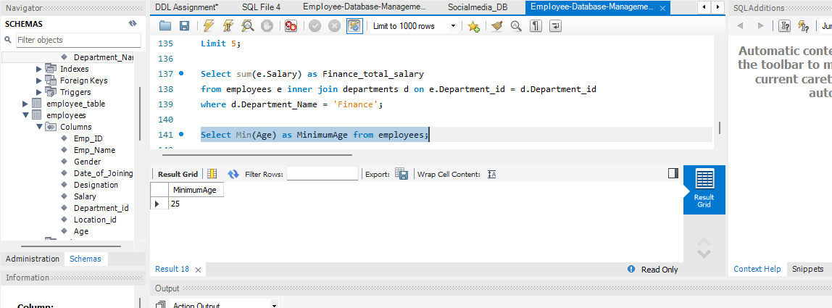

4. GROUP BY:

● List the maximum salary for each location.
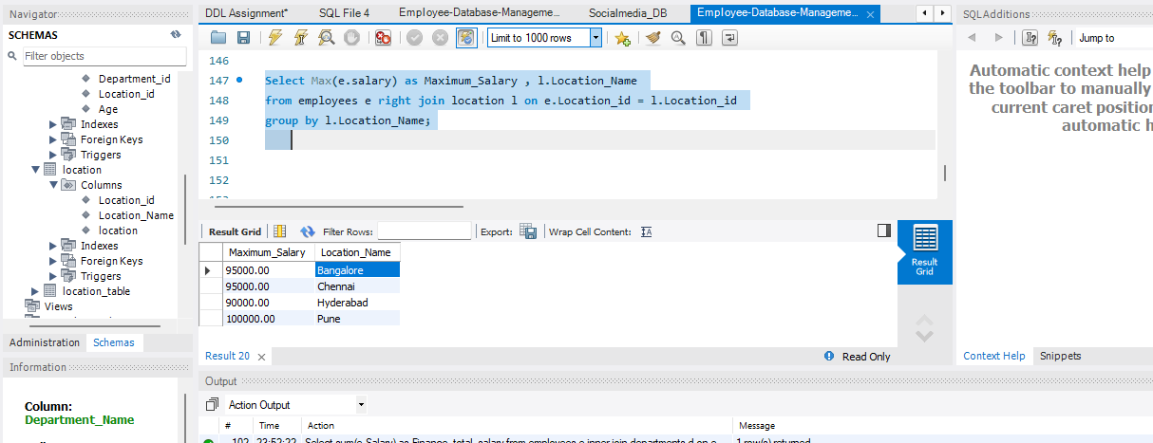

Calculate the average salary for each designation containing the word 'Analyst'.

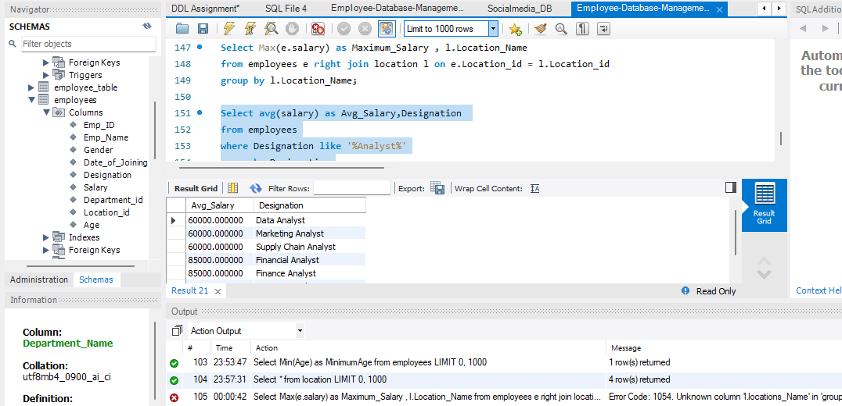

5. HAVING: ● Find departments with less than 3 employees.
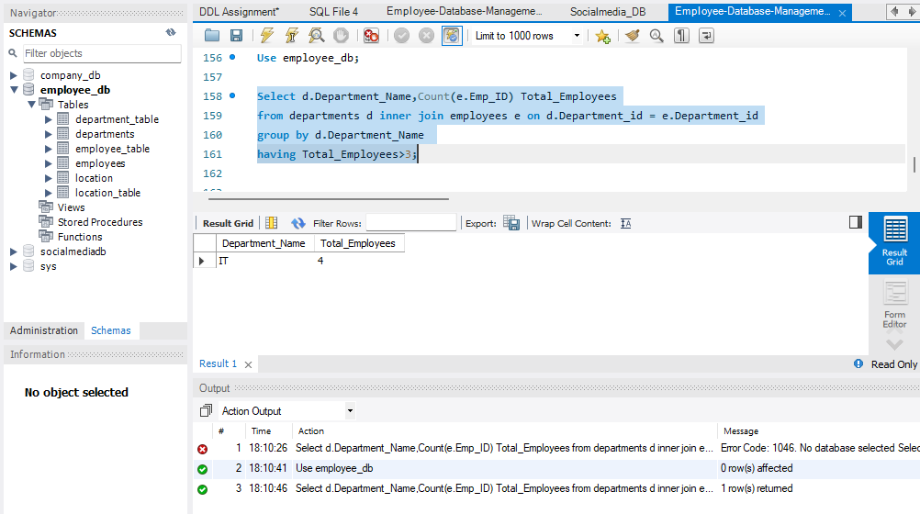

Find locations with female employees whose average age is below 30.
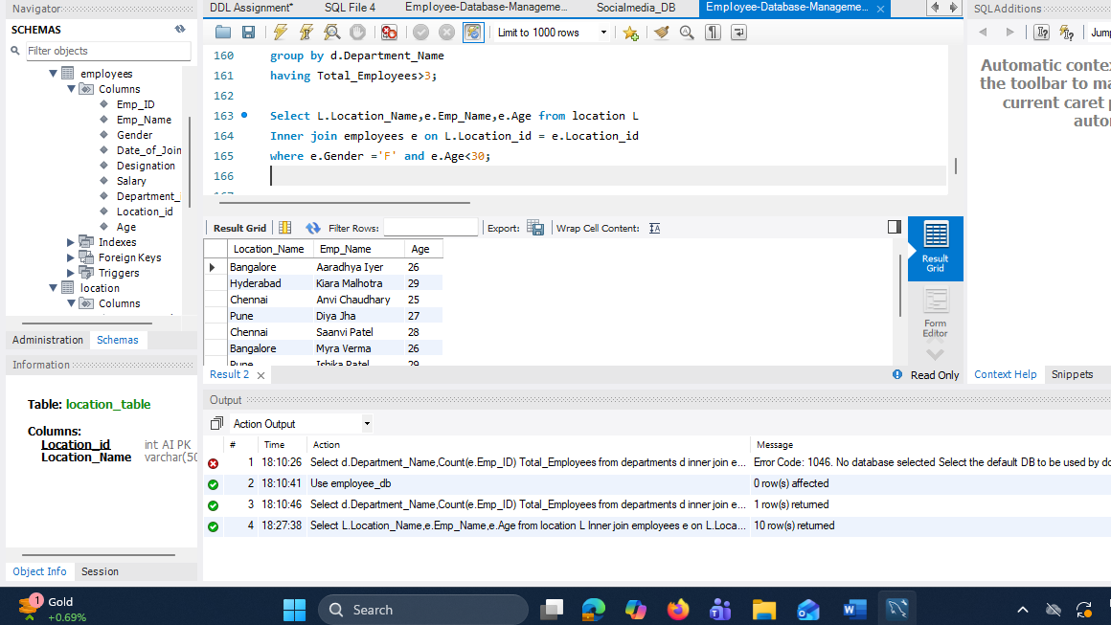
Joins: 1. INNER JOIN: ● List employee names, their designations, and department names where employees are assigned to a department.

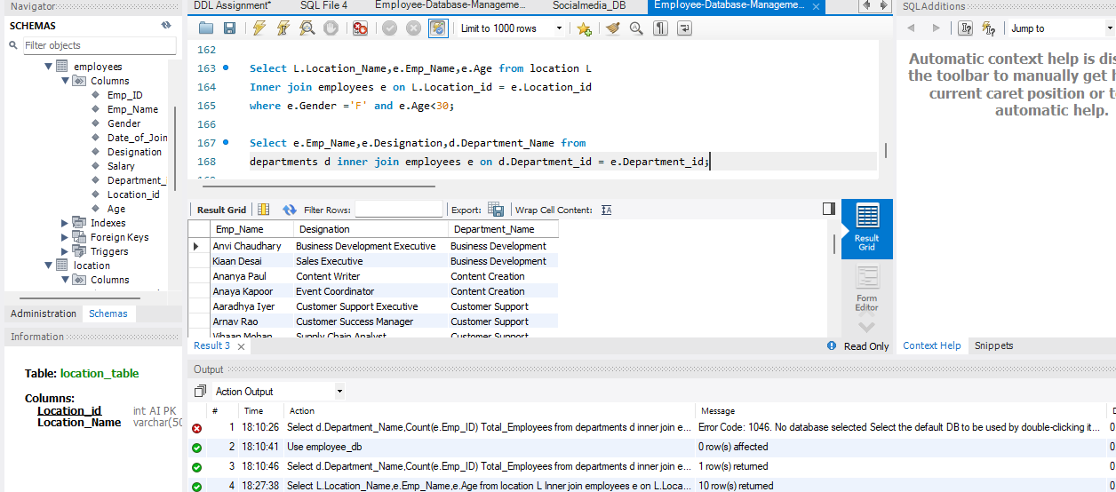

2. LEFT JOIN: ● List all departments along with the total number of employees in each department, including departments with no employees.
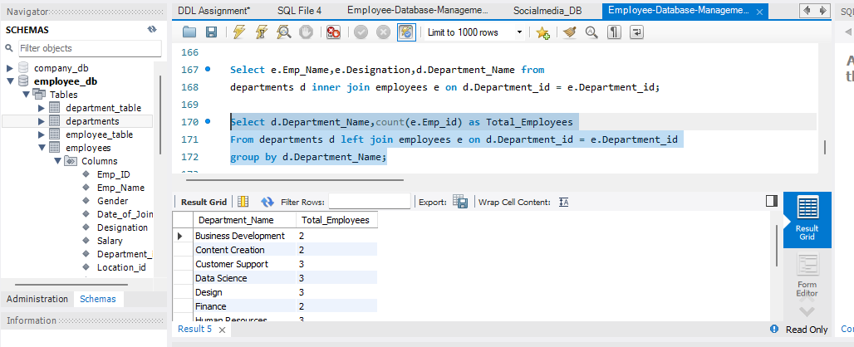

3. RIGHT JOIN: ● Display all locations along with the names of employees assigned to each location. If no employees are assigned to a location, display NULL for employee name.

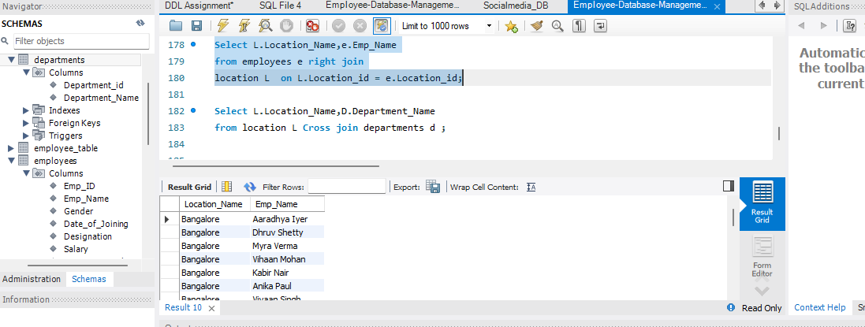

4. CROSS JOIN ● Show all possible combinations of departments and locations.

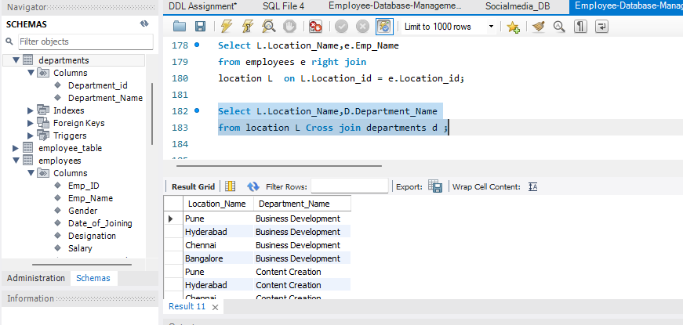
5. SELF JOIN: ● Show pairs of employees working in the same department, excluding self-pairs.
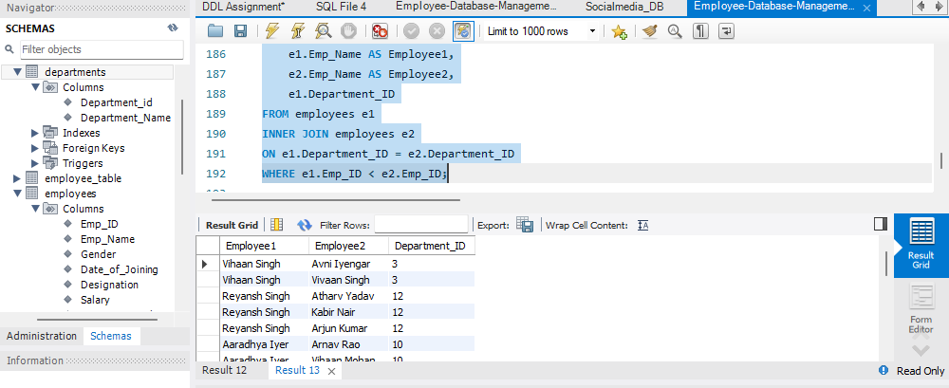

Windows function
● Write a window function query to rank employees by salary using rank().
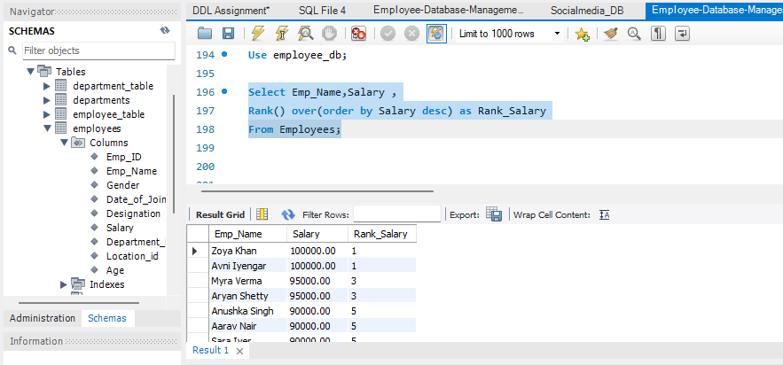
Write a window function query to rank employees by salary within each department
using DENSE_RANK()

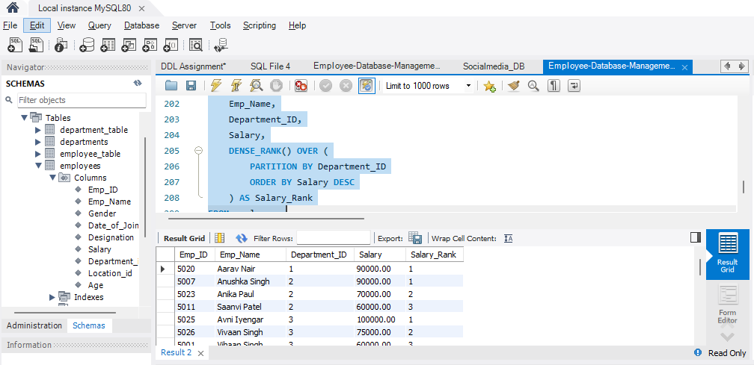
Write a window function query, Running total salary by department
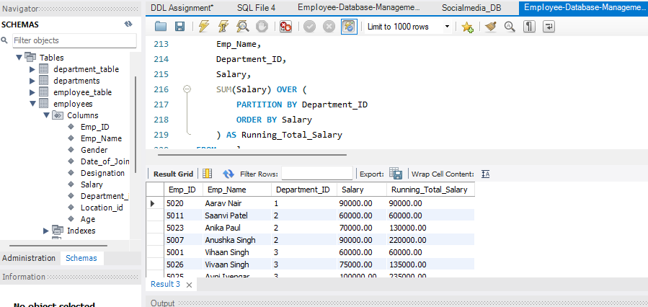

Conclusion
This project provided hands-on experience in SQL data querying and business analysis using MySQL. It demonstrates proficiency in retrieving, filtering, sorting, grouping, and aggregating relational data while implementing JOIN operations and Window Functions to solve real-world business problems. The assignment strengthened analytical thinking, SQL query optimization, and database querying skills, establishing a solid foundation for advanced SQL, data analytics, and business intelligence applications

